
Parameter
Basic Parameter
Applicable models: HFT11

HFT11 | Technical parameters | Unit
Overall weight |  | kg | 1050
Bucket capacity |  | m3 | 0.02
Type of working device |  |  | Backhoe
Engine | Model |  | Koop 192F
Engine | Displacement | L | 0.898
Engine | Rated output power/speed | kw/r/min | 11.8/2300
Engine | Maximum  torque/rotating speed | N.m/r/min | 51.3/1800
Speed | Maximum traveling speed (High/low) | km/h | 1.5
Speed | Slewing speed | rpm | 11
Speed | Maximum grade ability |  | 30%
Track sub assembly | Ground pressure | k Pa | 34.64
Track sub assembly | Material |  | Rubber
Track sub assembly | Tension control type |  | Tightening cylinder
Type of pump |  |  | gear pump
Fuel/oil/fluid  pressure and  capacity | Working pressure | Mpa | 16
Fuel/oil/fluid  pressure and  capacity | Flow | (L/min) | 18.4
Fuel/oil/fluid  pressure and  capacity | Hydraulic oil tank capacity | (L) | 16
Fuel/oil/fluid  pressure and  capacity | Fuel tank capacity | (L) | 11

All ratings of the machine are obtained when the machine is operating on a solid horizontal support surface. If the working environment conditions of the machine differ from the above-mentioned reference conditions (Such as the operations on uneven ground and slope), the operator shall take these conditions into consideration.

7-2

Parameter
Overall Dimensions of Machine
Applicable models: HFT11

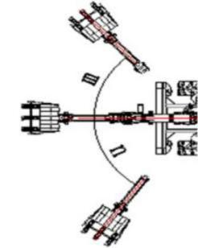
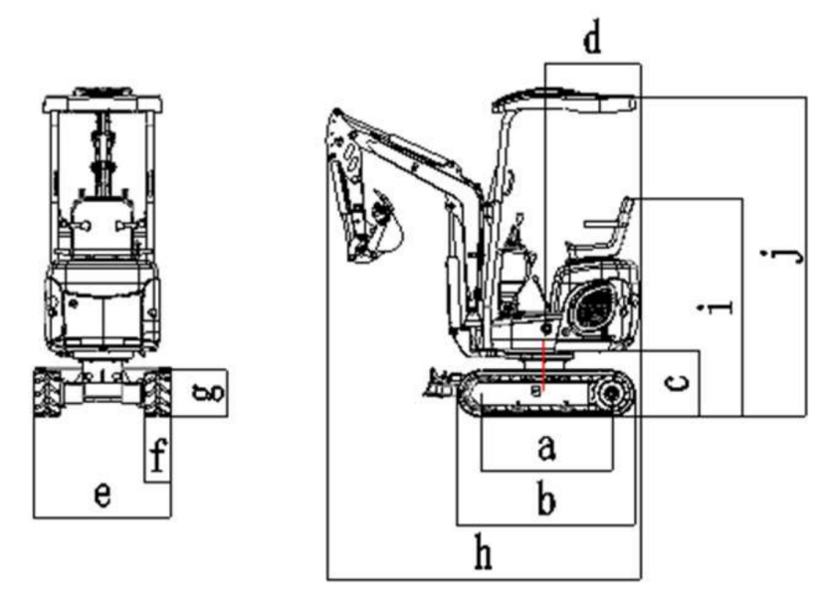

 | Overall dimensions | Unit: mm
a | Wheel track | 910
b | Overall length of crawler | 1235
c | Ground clearance of platform | 460
d | Tail slewing radius of platform | 660
e | Chassis width | 800-950
f | Track width | 180
g | Track height | 320
h | Transport length | 2170/2850
i | Ground clearance of seat | 1520
j | Overall height | 2270
m | Boom slewing - right | 50。
n | Boom slewing – left | 55。
7-3

Parameter
Operating Range
Applicable models: HFT11
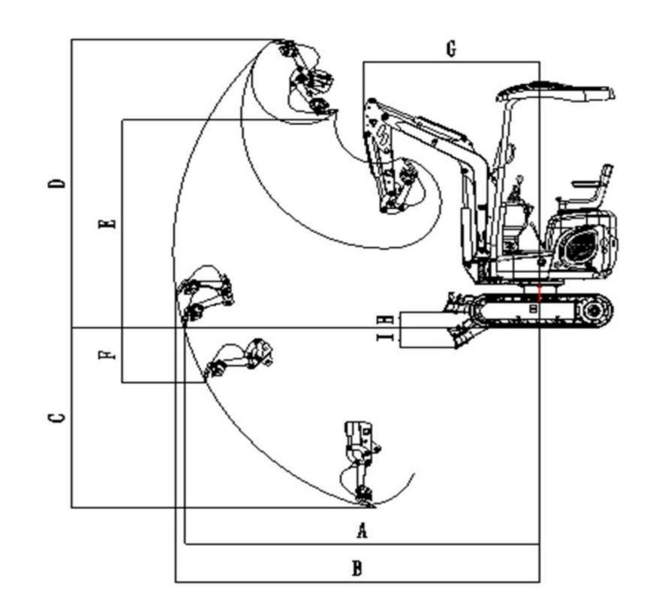

Working range mm

A | Ground maximum digging radius | 3040
B | Maximum digging radius | 3135
C | Maximum digging depth | 1580
D | Maximum digging height | 2620
E | Maximum Dump height | 2000
F | Maximum vertical digging depth | 1580
G | Minimum slewing radius | 1510
H | Maximum lifting height of bulldozing blade | 140
I | Maximum digging depth of bulldozing blade | 200

